**REQUIREMENTS NOT MET**

-Bullet point here any parts of the lab you were unable to complete prior to the lab.

-Omit this section for the lab write up.

**PROBLEMS ENCOUNTERED**

-As you go through the lab, bullet point any issues you had during the lab, so essentially any parts of the lab you had trouble understanding or getting to work correctly. This is helpful for me in helping you debug your circuits, and for you in fixing any future problems you have when putting the lab modules together for your final project.

-Omit this section for the lab write up.

**INTRODUCTION**

-For your write up, write a brief introduction to what you are doing in the in lab. two to four sentences.

-Omit this section for the prelab.

**DISCUSSION**

TIPS:

-In the write up, Reference your prelab calculations when proper.

-In the prelab and write up, label figures and tables with descriptions.

**1.4.1 The first section the lab**

Have a description here of what is occurring in this part of the lab. One to two sentences. Do this for each section of the lab.

|  |  |  |  |
| --- | --- | --- | --- |
| **Output Voltage Pulse** | **First Found** |  |  |
| **Mono-stable configuration** |  | 4.59k[Ω] | -2.34% |
| **A-stable configuration** | 10k[Ω] | 9.80k[Ω] | -2.00% |

**Table 1:** Table is here as an example. Include tables, and figures as proper for each section.

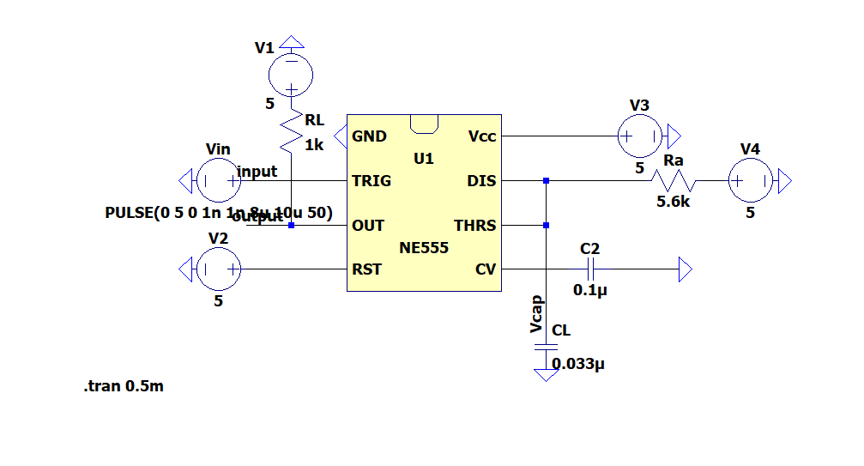

**Figure 1:** Circuit for something you will learn about later. Include a one to two sentence description of your figure.

**Discussion Question (write-up only): Each lab will have one to several questions to answer about the in lab. Do this here. No answer to a single question should need to be more than 4 sentences but ensure you right enough to fully prove/ flesh out your answer. I recommend typing it in bold.**

**CONCLUSION**

**This should be 2 to 4 sentences, for the write up only explaining overall what you specifically carried out in this particular lab.**

-Omit this section for the prelab.